

Chinese Medicine Board of Australia

Registrant data

Reporting period: 1 January 2018 – 31 March 2018

Table of contents
Introduction 3
Principal place of practice 4
1. Registration type 4
2. Registration divisions 5
Age group 6
3. Registration type 6
Gender 7
4. Registration type 7
5. Percentage 7

Introduction
The functions of the Chinese Medicine Board of Australia (the Board) include:
- registering Chinese medicine practitioners and students
- developing standards, codes and guidelines for the Chinese Medicine profession
- handling notifications, complaints, investigations and disciplinary hearings
- overseeing the assessment of overseas trained practitioners who wish to practise in Australia, and
- approving accreditation standards and accredited courses of study.
The Board’s functions are supported by the Australian Health Practitioner Regulation Agency (AHPRA). For information about legislation governing our operations see AHPRA's Legislation & Publications at www.ahpra.gov.au/Publications
The Board has analysed its registration data and produced a number of statistical breakdowns about registrants to share with the profession and community. The Board shares these breakdowns regularly.
For more information on Chinese Medicine registration, please see the Board’s website: www.chinesemedicineboard.gov.au/Registration.aspx

Principal place of practice
- Registration type
  - Registration type by principal place of practice
Registration Type | ACT | NSW | NT | QLD | SA | TAS | VIC | WA | No PPP | Total
General | 63 | 1,900 | 12 | 830 | 179 | 34 | 1,232 | 247 | 59 | 4,556
General and non-practising |  | 1 |  |  |  |  |  | 1 |  | 2
Limited |  | 2 |  |  |  |  |  |  |  | 2
Non-practising | 2 | 74 | 1 | 44 | 5 |  | 70 | 16 | 73 | 285
Total | 65 | 1,977 | 13 | 874 | 184 | 34 | 1,302 | 264 | 132 | 4,845

  - Registration type by principal place of practice percentages

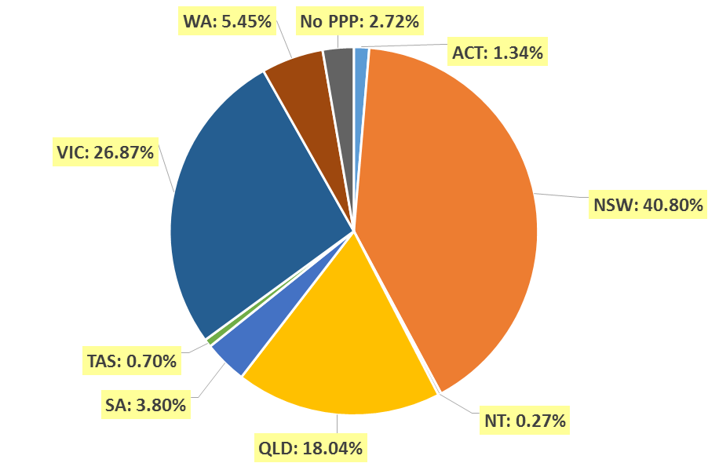

- Registration divisions
  - Registrations by division
Divisions | ACT | NSW | NT | QLD | SA | TAS | VIC | WA | No PPP | Total
Acupuncturist | 23 | 424 | 7 | 571 | 107 | 22 | 422 | 97 | 27 | 1,700
Acupuncturist and Chinese herbal dispenser |  | 1 |  | 2 |  |  |  |  |  | 3
Acupuncturist and Chinese herbal dispenser and Chinese herbal medicine practitioner | 7 | 525 | 2 | 61 | 12 | 2 | 211 | 38 | 33 | 891
Acupuncturist and Chinese herbal medicine practitioner | 35 | 960 | 4 | 229 | 64 | 10 | 640 | 127 | 68 | 2,137
Chinese herbal dispenser |  | 32 |  | 2 |  |  | 4 | 2 | 1 | 41
Chinese herbal dispenser and Chinese herbal medicine practitioner |  | 13 |  | 1 | 1 |  | 3 |  | 1 | 19
Chinese herbal medicine practitioner |  | 22 |  | 8 |  |  | 22 |  | 2 | 54
Total | 65 | 1,977 | 13 | 874 | 184 | 34 | 1,302 | 264 | 132 | 4,845

Age group
- Registration type
  - Registration type by age group
Age group | General | General and non-practising | Limited | Non-practising | Total
U - 25 | 25 |  |  |  | 25
25 - 29 | 199 |  |  | 11 | 210
30 - 34 | 364 |  | 1 | 31 | 396
35 - 39 | 542 | 1 |  | 48 | 591
40 - 44 | 634 |  |  | 42 | 676
45 - 49 | 635 |  | 1 | 24 | 660
50 - 54 | 563 |  |  | 39 | 602
55 - 59 | 629 | 1 |  | 33 | 663
60 - 64 | 527 |  |  | 29 | 556
65 - 69 | 268 |  |  | 18 | 286
70 - 74 | 109 |  |  | 7 | 116
75 - 79 | 42 |  |  | 3 | 45
80+ | 19 |  |  |  | 19
Total | 4,556 | 2 | 2 | 285 | 4,845

  - Registrants by age group

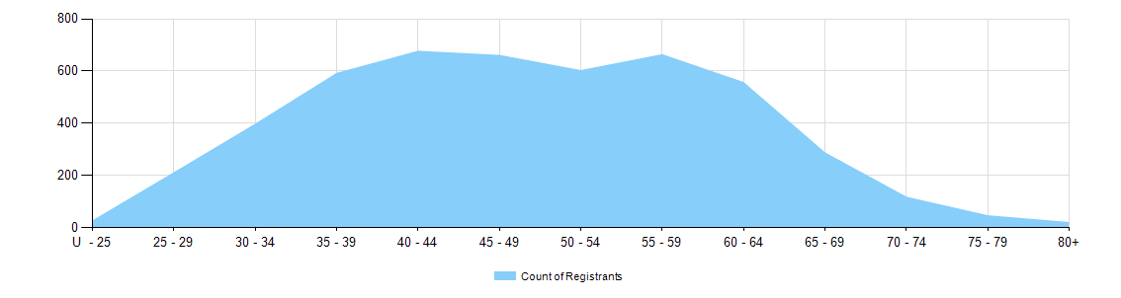

Gender
- Registration type
  - Registration type by gender
Gender | Registration type | ACT | NSW | NT | QLD | SA | TAS | VIC | WA | No PPP | Total
Female | General | 33 | 1,029 | 9 | 453 | 96 | 20 | 696 | 152 | 33 | 2,521
Female | General and non-practising |  |  |  |  |  |  |  | 1 |  | 1
Female | Limited |  | 1 |  |  |  |  |  |  |  | 1
Female | Non-practising | 2 | 49 |  | 31 | 3 |  | 47 | 10 | 38 | 180
Total female |  | 35 | 1,079 | 9 | 484 | 99 | 20 | 743 | 163 | 71 | 2,703
Male | General | 30 | 871 | 3 | 377 | 83 | 14 | 536 | 95 | 26 | 2,035
Male | General and non-practising |  | 1 |  |  |  |  |  |  |  | 1
Male | Limited |  | 1 |  |  |  |  |  |  |  | 1
Male | Non-practising |  | 25 | 1 | 13 | 2 |  | 23 | 6 | 35 | 105
Total male |  | 30 | 898 | 4 | 390 | 85 | 14 | 559 | 101 | 61 | 2,142
Total |  | 65 | 1,977 | 13 | 874 | 184 | 34 | 1,302 | 264 | 132 | 4,845

- Percentage
  - Registration by gender percentages
Gender | ACT | NSW | NT | QLD | SA | TAS | VIC | WA | No PPP | Total
Female | 53.8% | 54.6% | 69.2% | 55.4% | 53.8% | 58.8% | 57.1% | 61.7% | 53.8% | 55.8%
Male | 46.2% | 45.4% | 30.8% | 44.6% | 46.2% | 41.2% | 42.9% | 38.3% | 46.2% | 44.2%

