Chinese Medicine Registrant Data: March 2013

Published April 2013
Introduction
The functions of the Chinese Medicine Board of Australia include:
- registering registering Chinese medicine practitioners and students
- developing standards, codes and guidelines for the Chinese Medicine profession
- handling notifications, complaints, investigations and disciplinary hearings
- assessing overseas trained practitioners who wish to practise in Australia
- approving accreditation standards and accredited courses of study.

The Board’s functions are supported by Australian Health Practitioner Regulation Agency (AHPRA). For information about legislation governing our operations see AHPRA's Legislation & Publications at http://www.ahpra.gov.au/Legislation-and-Publications.aspx

The Board has analysed its third quarter of registration data and produced a number of statistical breakdowns about registrants to share with the profession and community.

The Board shares these breakdowns regularly. In the context of “grandparenting”, as registration applications are finalised a clearer picture of the profession will emerge.

For more information on Chinese Medicine registration, please see the Board’s website www.chinesemedicineboard.gov.au/Registration.aspx

Index of Tables
Chinese Medicine Practitioners: State and territory by registration type 2
Chinese Medicine Practitioners: Age by registration type 3
Chinese Medicine Practitioners: Gender by state and territory by registration type 4
Chinese Medicine Practitioners: Registration numbers by division by state and territory 4

Chinese medicine practitioners: State and territory by registration type
State | General | Limited | Non-practising | Total | % By State
 |  | Teaching or research
ACT | 62 |  | 1 | 63 | 1.58%
NSW | 1,605 |  | 5 | 1,610 | 40.26%
NT | 12 |  | 8 | 20 | 0.5%
QLD | 765 | 1 | 7 | 773 | 19.33%
SA | 155 |  |  | 155 | 3.88%
TAS | 31 |  |  | 31 | 0.78%
VIC | 1,068 |  | 62 | 1,130 | 28.26%
WA | 186 |  | 1 | 187 | 4.68%
Not Stated | 17 |  | 13 | 30 | 0.75%
Total | 3,901 | 1 | 97 | 3,999

% By state and territory
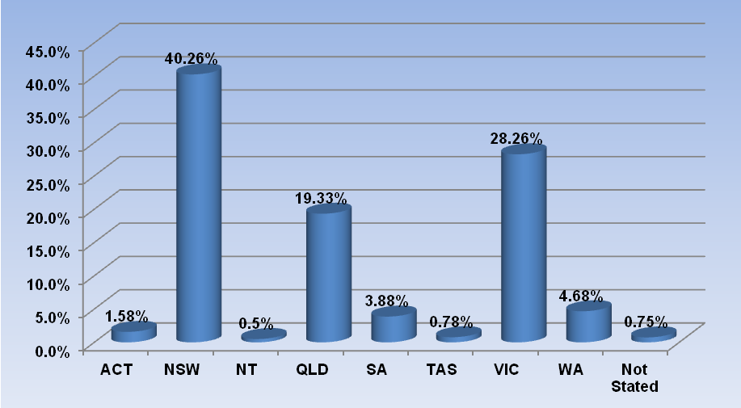

Chinese medicine practitioners: age by registration type
Age Group | General | Limited | Non-practising | Total | % By Age Group
 |  | Teaching or research
21 - 25 | 38 |  | 1 | 39 | 0.98%
26 - 30 | 238 |  | 6 | 244 | 6.1%
31 - 35 | 419 |  | 11 | 430 | 10.75%
36 - 40 | 531 |  | 21 | 552 | 13.8%
41 - 45 | 521 |  | 16 | 537 | 13.43%
46 - 50 | 510 |  | 6 | 516 | 12.9%
51 - 55 | 559 |  | 17 | 576 | 14.4%
56 - 60 | 524 | 1 | 9 | 534 | 13.35%
61 - 65 | 320 |  | 5 | 325 | 8.13%
66 - 70 | 138 |  | 2 | 140 | 3.5%
71 - 75 | 60 |  | 2 | 62 | 1.55%
76 - 80 | 37 |  | 1 | 38 | 0.95%
81 - 85 | 5 |  |  | 5 | 0.13%
86 + | 1 |  |  | 1 | 0.03%
Total | 3,901 | 1 | 97 | 3,999

% By age
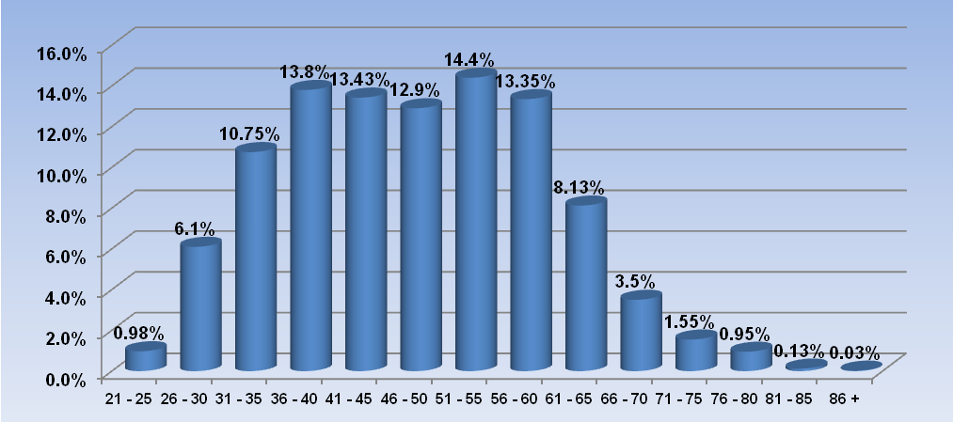

Chinese medicine practitioners: Gender by state and territory by registration type
Sex | State | General | Limited | Non-practising | Total Count | % By Sex By State
 |  |  | Teaching or research
Female | ACT | 32 |  | 1 | 33 | 0.83%
Female | NSW | 824 |  | 2 | 826 | 20.66%
Female | NT | 9 |  | 5 | 14 | 0.35%
Female | QLD | 399 |  | 4 | 403 | 10.08%
Female | SA | 82 |  |  | 82 | 2.05%
Female | TAS | 18 |  |  | 18 | 0.45%
Female | VIC | 575 |  | 42 | 617 | 15.43%
Female | WA | 111 |  | 1 | 112 | 2.8%
Female | Not Stated | 10 |  | 5 | 15 | 0.38%
Female | Sub total | 2,060 |  | 60 | 2,120 | 53.01%
Male | ACT | 30 |  |  | 30 | 0.75%
Male | NSW | 780 |  | 3 | 783 | 19.6%
Male | NT | 3 |  | 3 | 6 | 0.15%
Male | QLD | 366 | 1 | 3 | 370 | 9.25%
Male | SA | 73 |  |  | 73 | 1.83%
Male | TAS | 13 |  |  | 13 | 0.33%
Male | VIC | 492 |  | 20 | 512 | 12.8%
Male | WA | 75 |  |  | 75 | 1.88%
Male | Not Stated | 7 |  | 8 | 15 | 0.38%
Male | Sub total | 1,839 | 1 | 37 | 1,877 | 46.96%
Male | NSW | 1 |  |  | 1 | 19.6%
Male | Sub total | 1 |  |  | 1 | 46.96%
Not Stated | VIC | 1 |  |  | 1 | 0.03%
Not Stated | Sub total | 1 |  |  | 1 | 0.03%
Total |  | 3,901 | 1 | 97 | 3,999

Chinese medicine practitioners: Registration numbers by division, by state and territory

 | ACT | NSW | NT | QLD | SA | TAS | VIC | WA | No PPP | Total
Acupuncturist | 22 | 402 | 6 | 523 | 84 | 18 | 414 | 65 | 4 | 1,538
Acupuncturist and Chinese Herbal Dispenser |  | 1 |  | 4 |  |  |  |  |  | 5
Acupuncturist and Chinese Herbal Dispenser and Chinese Herbal Medicine Practitioner | 6 | 326 |  | 36 | 7 |  | 30 | 15 |  | 420
Acupuncturist and Chinese Herbal Medicine Practitioner | 34 | 815 | 7 | 204 | 61 | 13 | 660 | 101 | 25 | 1,920
Chinese Herbal Dispenser |  | 32 |  |  | 1 |  | 3 | 2 |  | 38
Chinese Herbal Dispenser and Chinese Herbal Medicine Practitioner |  | 11 |  |  | 2 |  |  |  |  | 13
Chinese Herbal Medicine Practitioner | 1 | 25 |  | 6 | 2 | 1 | 26 | 4 |  | 65
Chinese Medicine Practitioner | 63 | 1,612 | 13 | 773 | 157 | 32 | 1,133 | 187 | 29 | 3,999

