Chinese Medicine Registrant Data: December 2012

Published January 2013
Introduction
The functions of the Chinese Medicine Board of Australia include:
- registering registering Chinese medicine practitioners and students
- developing standards, codes and guidelines for the Chinese Medicine profession
- handling notifications, complaints, investigations and disciplinary hearings
- assessing overseas trained practitioners who wish to practise in Australia
- approving accreditation standards and accredited courses of study.

The Board’s functions are supported by Australian Health Practitioner Regulation Agency (AHPRA). For information about legislation governing our operations see AHPRA's Legislation & Publications at http://www.ahpra.gov.au/Legislation-and-Publications.aspx

The Board has analysed its second quarter of registration data and produced a number of statistical breakdowns about registrants to share with the profession and community.

The Board shares these breakdowns regularly. In the context of “grandparenting”, as registration applications are finalised a clearer picture of the profession will emerge.

For more information on Chinese Medicine registration, please see the Board’s website www.chinesemedicineboard.gov.au/Registration.aspx

Index of Tables
Chinese Medicine Practitioners: State and territory by registration type 2
Chinese Medicine Practitioners: Age by registration type 3
Chinese Medicine Practitioners: Gender by state and territory by registration type 4
Chinese Medicine Practitioners: Registration numbers by division, by state and territory 4

Please Note: The numbers in this report reflect the National Board’s registration data as at 31 December 2012. These statistics include approximately 105 registrants who did not renew their registration by the end of the registration renewal late period for this profession, and were removed from the register on 3 January 2013, as required by the National Law.
Chinese medicine practitioners: State and territory by registration type
State | General | Limited |  | Non-practising | Total | % By State
 |  | Public interest | Teaching or research
ACT | 61 |  |  | 1 | 62 | 1.57%
NSW | 1,576 | 9 |  | 6 | 1,591 | 40.26%
NT | 12 |  |  | 8 | 20 | 0.51%
QLD | 753 | 7 | 1 | 3 | 764 | 19.33%
SA | 151 |  |  | 1 | 152 | 3.85%
TAS | 30 |  |  |  | 30 | 0.76%
VIC | 1,051 | 1 |  | 66 | 1,118 | 28.29%
WA | 181 | 4 |  |  | 185 | 4.68%
Not Stated | 17 |  |  | 13 | 30 | 0.76%
Total | 3,832 | 21 | 1 | 98 | 3,952

% By state and territory
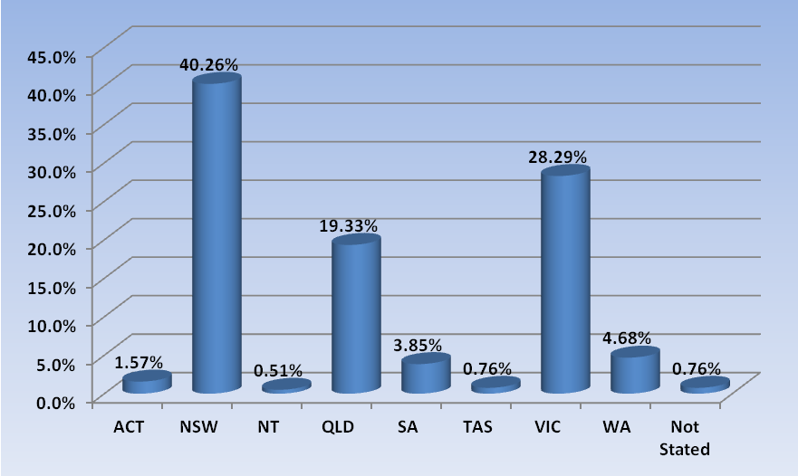

Chinese medicine practitioners: age by registration type
Age Group | General | Limited |  | Non-practising | Total | % By Age Group
 |  | Public interest | Teaching or research
21 - 25 | 30 |  |  |  | 30 | 0.76%
26 - 30 | 223 | 1 |  | 6 | 230 | 5.82%
31 - 35 | 413 | 2 |  | 16 | 431 | 10.91%
36 - 40 | 531 | 1 |  | 20 | 552 | 13.97%
41 - 45 | 513 | 1 |  | 12 | 526 | 13.31%
46 - 50 | 504 | 4 |  | 8 | 516 | 13.06%
51 - 55 | 549 | 5 |  | 15 | 569 | 14.4%
56 - 60 | 516 | 2 | 1 | 9 | 528 | 13.36%
61 - 65 | 313 | 4 |  | 6 | 323 | 8.17%
66 - 70 | 136 |  |  | 3 | 139 | 3.52%
71 - 75 | 60 | 1 |  | 2 | 63 | 1.59%
76 - 80 | 38 |  |  | 1 | 39 | 0.99%
81 - 85 | 5 |  |  |  | 5 | 0.13%
86 + | 1 |  |  |  | 1 | 0.03%
Total | 3,832 | 21 | 1 | 98 | 3,952

% By age
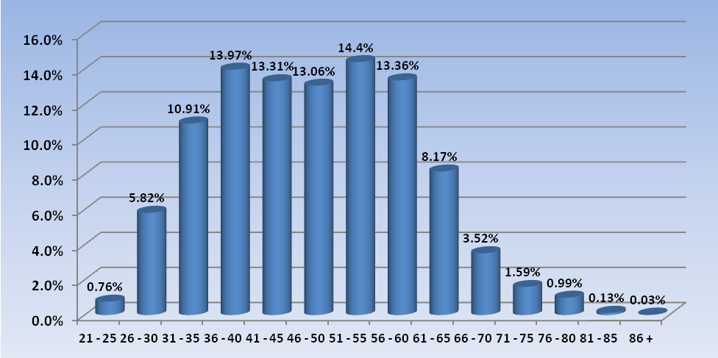

Chinese medicine practitioners: Gender by state and territory by registration type
Sex | State | General | Limited |  | Non-practising | Total Count | % By Sex By State
 |  |  | Public interest | Teaching or research
Female | ACT | 30 |  |  | 1 | 31 | 0.78%
Female | NSW | 813 | 4 |  | 4 | 821 | 20.77%
Female | NT | 9 |  |  | 5 | 14 | 0.35%
Female | QLD | 392 | 3 |  | 2 | 397 | 10.05%
Female | SA | 80 |  |  | 1 | 81 | 2.05%
Female | TAS | 17 |  |  |  | 17 | 0.43%
Female | VIC | 566 |  |  | 43 | 609 | 15.41%
Female | WA | 108 | 4 |  |  | 112 | 2.83%
Female | Not Stated | 10 |  |  | 5 | 15 | 0.38%
Female | Sub total | 2,025 | 11 |  | 61 | 2,097 | 53.06%
Male | ACT | 31 |  |  |  | 31 | 0.78%
Male | NSW | 763 | 5 |  | 2 | 770 | 19.48%
Male | NT | 3 |  |  | 3 | 6 | 0.15%
Male | QLD | 361 | 4 | 1 | 1 | 367 | 9.29%
Male | SA | 71 |  |  |  | 71 | 1.8%
Male | TAS | 13 |  |  |  | 13 | 0.33%
Male | VIC | 484 | 1 |  | 23 | 508 | 12.85%
Male | WA | 73 |  |  |  | 73 | 1.85%
Male | Not Stated | 7 |  |  | 8 | 15 | 0.38%
Male | Sub total | 1,806 | 10 | 1 | 37 | 1,854 | 46.91%
Not Stated | VIC | 1 |  |  |  | 1 | 0.03%
Not Stated | Sub total | 1 |  |  |  | 1 | 0.03%
Total |  | 3,832 | 21 | 1 | 98 | 3,952

Chinese medicine practitioners: Registration numbers by division, by state and territory
 | ACT | NSW | NT | QLD | SA | TAS | VIC | WA | No PPP | Total
Acupuncturist | 20 | 405 | 6 | 515 | 82 | 17 | 415 | 70 | 4 | 1,534
Acupuncturist and Chinese Herbal Dispenser | 1 | 2 |  | 3 |  |  |  |  |  | 6
Acupuncturist and Chinese Herbal Dispenser and Chinese Herbal Medicine Practitioner | 6 | 318 |  | 37 | 4 |  | 18 | 15 |  | 398
Acupuncturist and Chinese Herbal Medicine Practitioner | 34 | 798 | 7 | 203 | 64 | 13 | 655 | 95 | 26 | 1,895
Chinese Herbal Dispenser |  | 31 |  |  | 1 |  | 3 | 2 |  | 37
Chinese Herbal Dispenser and Chinese Herbal Medicine Practitioner |  | 12 |  |  | 1 |  |  |  |  | 13
Chinese Herbal Medicine Practitioner | 1 | 27 |  | 6 | 2 | 1 | 29 | 3 |  | 69
TOTAL | 62 | 1,593 | 13 | 764 | 154 | 31 | 1,120 | 185 | 30 | 3,952

