

Chinese Medicine Board of Australia

Registrant Data

Reporting period: 1 April 2017 – 30 June 2017

Table of contents
Introduction 3
Principal Place of Practice 4
1. Registration Type 4
2. Registration Divisions 5
Age Group 6
3. Registration Type 6
Gender 7
4. Registration Type 7
5. Percentage 7

Introduction
The functions of the Chinese Medicine Board of Australia (the Board) include:
- registering Chinese medicine practitioners and students
- developing standards, codes and guidelines for the Chinese Medicine profession
- handling notifications, complaints, investigations and disciplinary hearings
- overseeing the assessment of overseas trained practitioners who wish to practise in Australia, and
- approving accreditation standards and accredited courses of study.
The Board’s functions are supported by the Australian Health Practitioner Regulation Agency (AHPRA). For information about legislation governing our operations see AHPRA's Legislation & Publications at www.ahpra.gov.au/Publications
The Board has analysed its registration data and produced a number of statistical breakdowns about registrants to share with the profession and community. The Board shares these breakdowns regularly.
For more information on Chinese Medicine registration, please see the Board’s website: www.chinesemedicineboard.gov.au/Registration.aspx

Principal Place of Practice
- Registration Type
  - Registration Type by Principal Place of Practice
Registration Type | ACT | NSW | NT | QLD | SA | TAS | VIC | WA | No PPP | Total
General | 67 | 1,908 | 12 | 827 | 177 | 36 | 1,238 | 250 | 68 | 4,583
General and Non-practising |  | 1 |  |  |  |  |  | 1 | 1 | 3
Limited |  | 2 |  |  |  |  |  |  |  | 2
Non-practising | 1 | 73 | 2 | 45 | 5 |  | 70 | 13 | 63 | 272
Total | 68 | 1,984 | 14 | 872 | 182 | 36 | 1,308 | 264 | 132 | 4,860

  - Registration Type by Principal Place of Practice Percentages

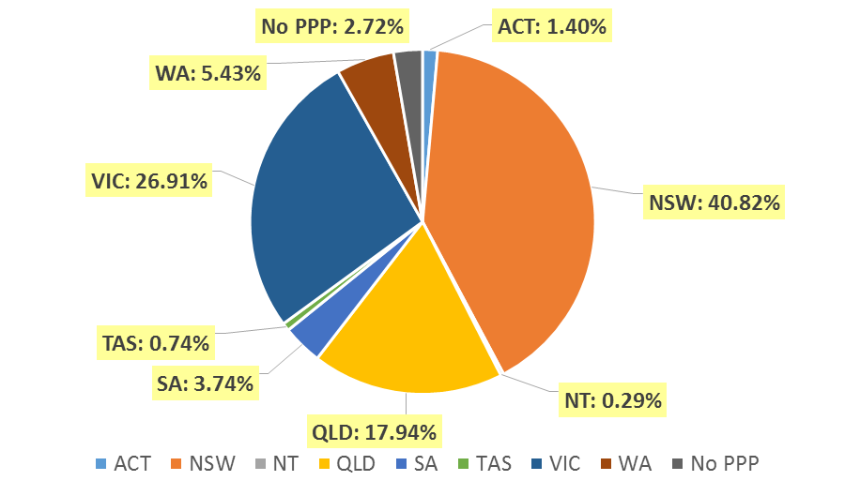

- Registration Divisions
  - Registrations by Division
Divisions | ACT | NSW | NT | QLD | SA | TAS | VIC | WA | No PPP | Total
Acupuncturist | 27 | 436 | 8 | 566 | 105 | 24 | 436 | 99 | 25 | 1,726
Acupuncturist and Chinese Herbal Dispenser |  | 1 |  | 2 |  |  |  |  |  | 3
Acupuncturist and Chinese Herbal Dispenser and Chinese Herbal Medicine Practitioner | 7 | 504 | 1 | 56 | 10 | 3 | 183 | 37 | 32 | 833
Acupuncturist and Chinese Herbal Medicine Practitioner | 34 | 973 | 5 | 236 | 64 | 9 | 660 | 126 | 71 | 2,178
Chinese Herbal Dispenser |  | 34 |  | 2 | 1 |  | 5 | 2 | 1 | 45
Chinese Herbal Dispenser and Chinese Herbal Medicine Practitioner |  | 13 |  | 2 | 2 |  | 2 |  | 1 | 20
Chinese Herbal Medicine Practitioner |  | 23 |  | 8 |  |  | 22 |  | 2 | 55
Total | 68 | 1,984 | 14 | 872 | 182 | 36 | 1,308 | 264 | 132 | 4,860

Age Group
- Registration Type
  - Registration type by Age Group
Age Group | General | General and Non-practising | Limited | Non-practising | Total
U - 25 | 31 |  |  |  | 31
25 - 29 | 213 |  |  | 17 | 230
30 - 34 | 365 |  | 1 | 33 | 399
35 - 39 | 585 | 1 |  | 43 | 629
40 - 44 | 645 |  |  | 37 | 682
45 - 49 | 603 |  | 1 | 26 | 630
50 - 54 | 601 |  |  | 32 | 633
55 - 59 | 616 | 2 |  | 36 | 654
60 - 64 | 517 |  |  | 24 | 541
65 - 69 | 253 |  |  | 14 | 267
70 - 74 | 92 |  |  | 7 | 99
75 - 79 | 42 |  |  | 3 | 45
80+ | 20 |  |  |  | 20
Total | 4,583 | 3 | 2 | 272 | 4,860

  - Registrants by Age Group

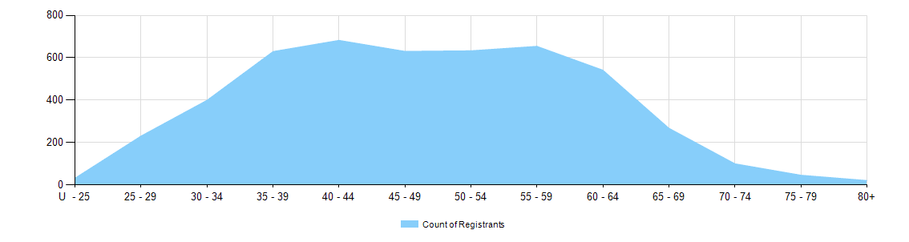

Gender
- Registration Type
  - Registration type by gender
Gender | Registration Type | ACT | NSW | NT | QLD | SA | TAS | VIC | WA | No PPP | Total
Female | General | 35 | 1,025 | 8 | 439 | 97 | 21 | 687 | 153 | 39 | 2,504
Female | General and Non-practising |  |  |  |  |  |  |  | 1 | 1 | 2
Female | Limited |  | 1 |  |  |  |  |  |  |  | 1
Female | Non-practising | 1 | 46 | 1 | 34 | 3 |  | 51 | 7 | 33 | 176
Total Female |  | 36 | 1,072 | 9 | 473 | 100 | 21 | 738 | 161 | 73 | 2,683
Male | General | 32 | 883 | 4 | 388 | 80 | 15 | 551 | 97 | 29 | 2,079
Male | General and Non-practising |  | 1 |  |  |  |  |  |  |  | 1
Male | Limited |  | 1 |  |  |  |  |  |  |  | 1
Male | Non-practising |  | 27 | 1 | 11 | 2 |  | 19 | 6 | 30 | 96
Total Male |  | 32 | 912 | 5 | 399 | 82 | 15 | 570 | 103 | 59 | 2,177
Total |  | 68 | 1,984 | 14 | 872 | 182 | 36 | 1,308 | 264 | 132 | 4,860

- Percentage
  - Registration by Gender Percentages
Gender | ACT | NSW | NT | QLD | SA | TAS | VIC | WA | No PPP | Total
Female | 52.9% | 54.0% | 64.3% | 54.2% | 54.9% | 58.3% | 56.4% | 61.0% | 55.3% | 55.2%
Male | 47.1% | 46.0% | 35.7% | 45.8% | 45.1% | 41.7% | 43.6% | 39.0% | 44.7% | 44.8%

